1. Create a table named SALES_REP. The table has the same structure as the REP table shown in Figure 3-11 except the LAST_NAME column should use the VARCHAR data type and the COMMISSION and RATE columns should use the NUMBER data type. Execute the command to describe the layout and characteristics of the SALES_REP table. 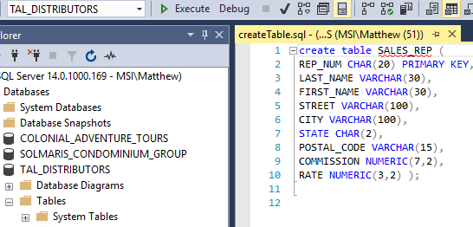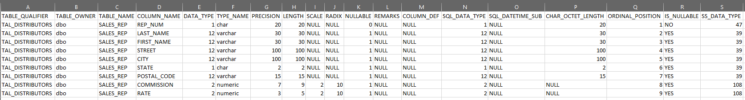

(The book showed different data types, but I put the ones that more accurately represents the data we would expect to handle)

1. Add the following row to the SALES_REP table: rep number: 35, last name: Lim; first name: Louise; street: 535 Vincent Dr.; city: Grove; state: CA; postal code: 90092; com- mission: 0.00; and rate: 0.05. Display the contents of the SALES_REP table.

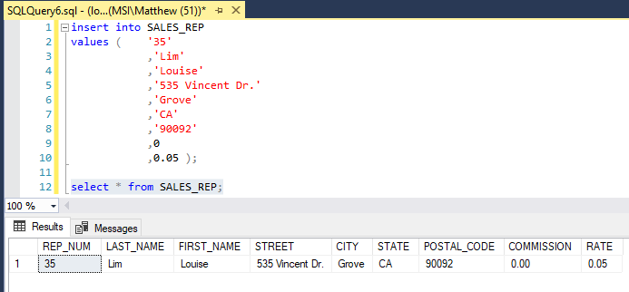

**3.** Delete the SALES_REP table.

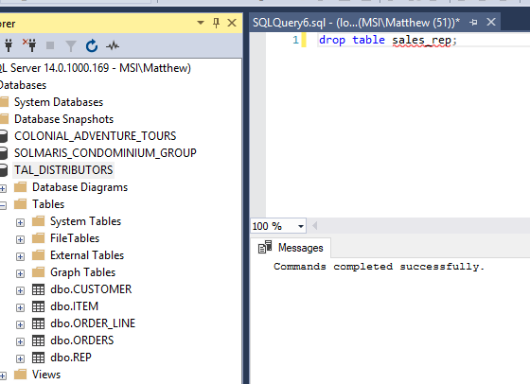

**4.** Run the script file for the TAL Distributors database to create the five tables and add records to the tables. Be sure to select the script file for the particular DBMS that you are using (Oracle, SQL Server, or Access). (Note: If you do not have the script files for this text, ask your instructor for assistance.)

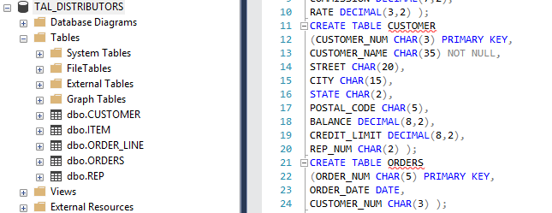

**5.** Confirm that you have created the tables correctly by describing each table and comparing the results to Figures 3-11, 3-30, 3-32, 3-34, and 3-36.

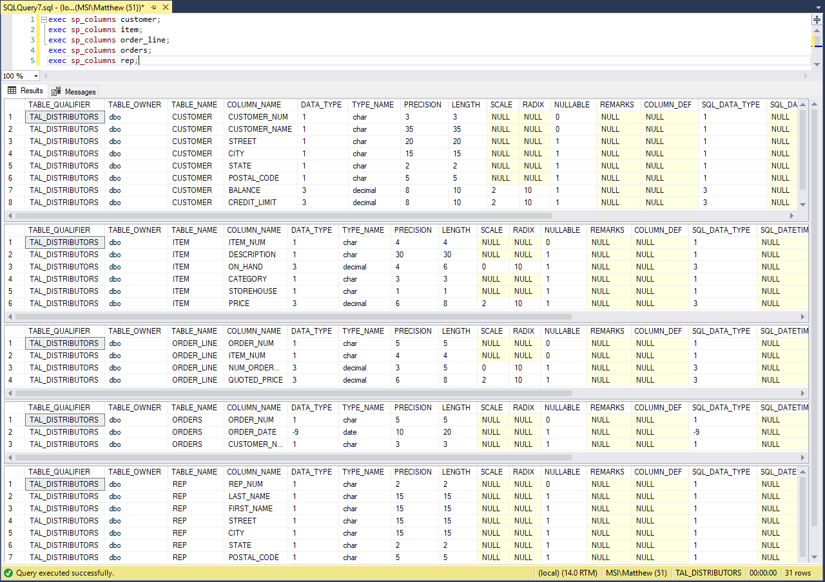

**6.** Confirm that you have added all data correctly by viewing the data in each table and comparing the results to Figure 2-1 in Chapter

